Chapel Point of View
One Lord, One Mission, Two Churches Serving Scioto Township
Global Methodist on Main & Scioto Chapel
April - May 2026

A Word from the Pastor – “Visioning”
The Scioto Chapel Church Council has decided to enter into a time of visioning to include anyone from the church who would like to participate. The same thing has been suggested at Global Methodist on Main at some point. I trust this process will be beneficial for the church and our directions forward as we try to move from stagnancy to healthy growth numerically and spiritually. We have invited an outside source from our conference to guide this visioning process.
Visioning can take many different forms, and our sessions together may lead to many different outcomes in the short-term and long-term. The focus is to seek where God is leading the church for the foreseeable future, as well as many years down the road. Some questions to consider include “where is God leading us?”, “what does God desire for our future?”, the emphasis on God and not our preferences. This requires prayer, maybe even the type of persevering prayer Jesus teaches in Luke 11:5-10, allowing God to mold our hearts in the process.
Most of us have heard the quote from Proverbs, “where there is no vision, the people perish” (29:18 KJV). Many times, we may feel like the children of Israel who eventually perished, wandering around in the wilderness for forty years. Or from Psalms, “unless the Lord builds the house, the builders labor in vain” (127:1 NIV). We can have many attempts and a lot of effort, but God is the One who wants to lead us in His ways and His direction.
So, what is God’s vision? Or as JD Walt likes to ask, “what is the church that Jesus is building?” Jesus states, referring to Peter’s declaration “you are the Christ, the Son of the living God” (Matthew 16:16), “I’ll build my church on this rock. The gates of the underworld won’t be able to stand against it” (v. 18 CEB). The goal in visioning is not to build something that is indestructible but to be centered on the One who is and His direction. Moreover, He has a plan; how does He want us to encapsulate it for our time and context and open the door for the years to come, where faith comes into action.
With this in mind, how would we look far off into the distance? What would God want us to see? Many times, to accomplish something big or long-lasting, it helps to look for the end, to get it into our sight. What is the God-sized dream that He would have for this area, how He wants to transform this area and beyond and people with His Good News? So, what do you see off in the distance? Maybe it’s something that will long out live you or any of us. And when we have something in sight, God can then set us on a trajectory, one step at a time, to head toward God’s desired future so that we can be actively involved in His Kingdom work.
So, what do you say? Is visioning together over multiple sessions a worthwhile pursuit? It requires faith, the core actualizer of Christianity. Let us be reminded of Jesus’ words “I assure you that if you have faith the size of a mustard seed, you could say to this mountain, ‘Go from here to there,’ and it will go. There will be nothing that you can’t do” (Matthew 17:20). And may we also be called forward by Mordecai’s words to Esther “for such a time as this” (Esther 4:14). Prayer is the starting point and what will lead us in each step. The facilitator will help guide the process, but vision will come from our connecting with God and our hearing God in one another. Let us be praying starting today for God’s vision.
Yours for the Kingdom of God here on earth as it is in heaven,
Pastor Brian
New Short-Term Discipleship Study
The Pastor is leading a new short-term discipleship study on the book of Ephesians. The study will be at 2:30pm on Wednesdays at Scioto Chapel starting the Wednesday after Easter (April 8th) and looking to conclude at the end of May. Each week we look at a short passage of the scripture (roughly 8-12 verses) starting with the first chapter and ask basic questions of the text and then how it applies to our lives and following of Jesus. Please let Pastor Brian know if you are interested or just show up. We will be glad to have you!

Holy Hilarity Sunday
Holy Hilarity Sunday is set for our normal worship times at both churches on Sunday, April 12th (the Sunday after Easter) where the Kingdom of God is a Party! Everyone is invited to wear a costume or some special funny attire for the day (even if it’s just chicken leg socks like a HopeStrong student was wearing on a normal day) and bring a couple of jokes to put a smile on everyone’s faces. Short skits and funny songs are also appropriate for the service to add to the levity or any other comedy related acts anyone would like to share in good taste. We hope to celebrate “the joy of the Lord” because as Nehemiah 8:10 tells us it “is your strength” and “a cheerful heart is a good medicine” (Proverbs 17:22). Also, keeping with the first part of Nehemiah 8:10 “Go, eat rich food, and drink something sweet…and send portions of this to any who have nothing ready!” we will have our traditional breakfast at Scioto Chapel and a Carry-In Dinner at Global Methodist on Main following the worship services. Invite a friend. “Rejoice in the Lord always. I will say it again: Rejoice!” (Philippians 4:4).

Progressive Dinner 2026
Last year was such a hit for the inauguration of the 3-church Progressive Dinner, we decided to bring it back this year, bigger and better, in April! Those who participated from the three churches, South Bloomfield Methodist, Global Methodist on Main, and Scioto Chapel all enjoyed the fellowship between the three churches. The goal is getting to know one another better, as well as enjoying great food and a program put on by each church. This year the event will be on Saturday, April 18th, beginning at 1pm. We will begin with appetizers at South Bloomfield Family Room, then move to Global Methodist on Main for the main entrée and conclude at Scioto Chapel with desserts. RSVP is required by Sunday, April 12th with a limit of 30 from each church. Adults and children of all ages will enjoy the “moving” event.

Stage Righteous Show “Fish-Eyes”
Stage Righteous is a production group from Marysville Cornerstone GMC that does numerous events across multiple counties here in Ohio. On Friday, May 15th, 6:30pm at South Bloomfield Methodist Family Room they will perform their show “Fish-Eyes” for churched and unchurched people alike. This 90-minute performance will have an intermission of free snacks, desserts, and drinks. This show presents a heartwarming, funny, and poignant tour of the gospel through the eyes of the disciple brothers Peter and Andrew. We are asking each of you in this 3-church outreach to invite your friends and neighbors (not to come by yourself) and give them the free tickets if they are able to come. Think of it as evangelism in a no commitment, fun way! You can get the tickets at each church starting on Sunday, April 12th and each Sunday leading up to the show as long as some are still available (the tickets are only so we don’t overbook the night). This evening should prove to be an enjoyable and entertaining night out for all ages and families.

Combined Calendar of Events April – May 2026
Date | Event | Time | Weekly* | Location
4/1 | Choir Practice | 7:00pm | * | SC
4/1 | Men’s Meal & Discipleship Group studying Hebrews | 5:00 pm | * | GMM
4/1 | Women’s Discipleship Group - Women of the Bible | 5:30 pm | * | GMM
4/2 | Men’s Discipleship Group-studying the book of Revelation | 9:00 am | * | GMM
4/2 & 5/7 | Prayer Initiative | 2:00pm |  | SC
4/2 | Passover Seder in the Fellowship Hall | 7:00 pm |  | GMM
4/3 | Good Friday Service | 7:00 pm |  | SC
4/5 | Easter Sunrise Service followed by breakfast in the Parish Hall | 7:00 am |  | SC
4/5 | Worship Service featuring “Chimes” | 9:00 am | * | SC
4/5 | Pastries & Wired Word except Easter | 10:30 am | * | SC
4/5 | Worship Service | 10:45 am | * | GMM
4/6 | Women’s Christian Fellowship All welcome | 6:00pm New time! |  | SC
4/7 | Trustee Meeting | 6:00pm |  | GMM
4/8 | New Short-term Discipleship Group studying Ephesians | 2:30pm | * | SC
4/9 | Discipleship Group-starting the Gospel of Mark | 4:00pm | * | GMM
4/9 | Satellite Soul Sisters-contact Kathy Morris 740-412-3682 | 6:30pm-8:00pm | * | Darbyville Community
4/11 | Young Disciples (elementary age-parents welcome to stay) RSVP to Becky Bingham 614-753-5265 | 9:00-10:00am |  | GMM
4/12 | Holy Hilarity (carry-in dinner following at GMM) | 9:00 & 10:45am |  | SC & GMM
4/13 & 5/11 | GMM Ad Council | 6:00pm |  | GMM
4/14&5/12 | Sewing Guild | 2:00pm |  | GMM
4/14 | First Visioning Session with Rev. Tom Hanover | 6:30pm |  | SC
4/18 | Progressive Dinner--S Bloomfield for appetizers, GMM for the main entrée and SC for dessert | 1:00 pm--4:00 pm |  | SB, GMM, SC
4/19, 5/3 & 5/17 | Youth Group – all Middle & High School welcome | 6:00-7:30pm |  | GMM
4/20 & 5/18 | Teams 4 Him  Church Council | 6:00pm 7:00pm |  | SC
4/21 & 5/19 | Free Community Dinner Anyone welcome | 4:30-6:30pm |  | GMM
4/22 & 5-27 | Ladies Coffee at Pick ‘em Up Joe’s All ladies welcome! | 9:00 am |  | W Scioto-CP
4/26 & 5/24 | Community Cupboard Collection |  |  | GMM
4/27 | Sewing Guild Annual Spring Luncheon contact Sheila Writsel to coordinate ride shares | Noon |  | Wesley Glen
4/27 | Trustee Meeting | 7:00pm |  | SC
5/1 &  5/2 | Women’s Retreat- Registration required  Friday  Saturday | 6:00-- 10am-2pm |  | GMM
5/9 | Mother’s Day Breakfast | 9:00am |  | GMM
5/9 | Mother’s Day Luncheon | 1:00pm |  | SC
5/15 | Stage Righteous Show “Fish-Eyes” with Snack Intermission at South Bloomfield Family Room (Free Event but Tickets required) | 6:30pm |  | S Bloomfield Methodist
5/26 | SPRC meeting | 6:30 pm |  | SC
CP Free Store hours every Monday 6-8pm and every Saturday 10am to Noon



April Birthdays May Birthdays
DATE | NAME |  | DATE | NAME
2 | Ron Shipley |  | 1 | Rick Fruchey
5 | Sheri Townsend |  | 2 | Getitia Brown
11 | Esther Durrett |  | 2 | Luke Derouaux
11 | Norma Gochenour |  | 4 | Christine Lawless
12 | Mike Thomas |  | 4 | Charlie England
13 | Peggy Fausnaugh |  | 13 | Levi Alphin
13 | Sandy Fruchey |  | 19 | Larry Thomas
15 | Jim Kuzelka |  | 21 | Lynn Johnson
16 | Denise Oxley |  | 21 | Blade Ballard
16 | Franklin Smith |  | 27 | Karen Musselman
17 | Sonnia Green |  | 28 | Marc Thomas
19 | Jan Stevens |  | 30 | Brodie England
23 | Josephine Bowerman
23 | Carolyn Porter
25 | Betsy Adams
26 | Sandy Crego
27 | Lily Patterson
27 | Eula Marks
28 | Katelyn Fausnaugh
28 | Becky Davis



April Anniversaries May Anniversaries
DATE | NAME |  | DATE | NAME
 |  |  | 2 | Ron & Karan Shipley
 |  |  | 6 | John & Rebecka Crego
 |  |  | 14 | Tony & Melissa Merriman
 |  |  | 16 | Denny & Janet Hutchins
 |  |  | 17 | Lee & Shannon Fausnaugh
 |  |  | 28 | Russ & Jackie Bowerman
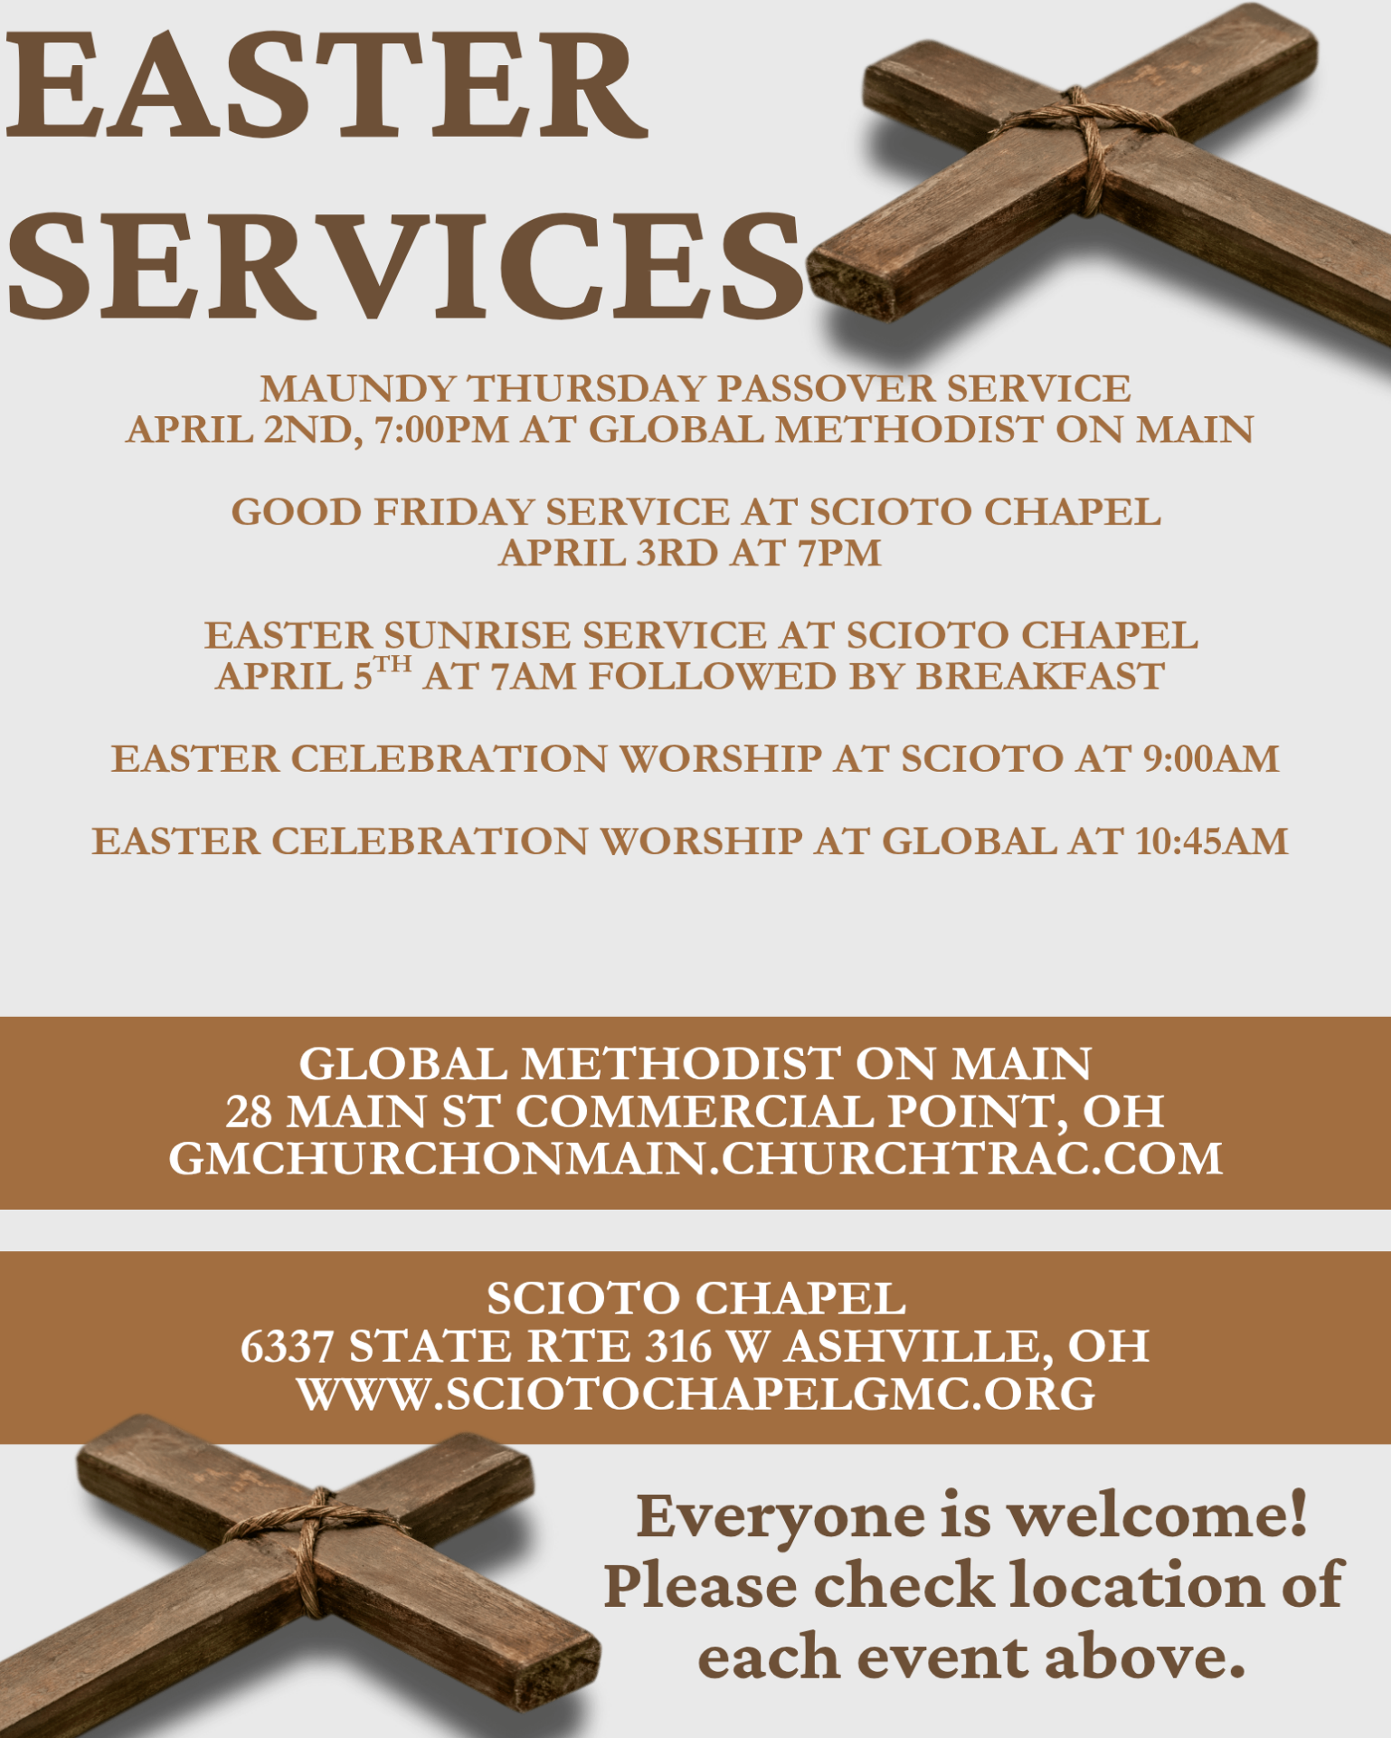
Global Methodist on Main
28 Main Street, Commercial Point, Ohio 43116 www.gmchurchonmain.churchtrac.com
614-877- 3539 Church Service 10:45 AM April-May 2026


The Young Disciples will be stuffing animals for Riverside’s Sewing Guild April 11, 2026. We will be meeting at Global Methodist on Main at 9:00am. If you would like to come and check us out, please do so, but don’t be late as we meet for one hour. Are you hesitant because you don’t know who will be there? Ask a friend to come with you and meet the friends you have not met yet. See you there! All children P-K through 5th grade are welcomed. Questions? Call Becky Bingham at 614-753-5265.

On March 7, 2026 Melissa Merriman and I (Becky Bingham) attended the Awaken + Equip session of Women of Evangelism. I was eager to hear what was said about this topic and a bit skeptical as well. My skepticism was soooo unwarranted. Well worth the trip. Why? The speakers were very VERY good...personal experiences that the audience could relate too, and maybe just maybe have her eyes opened to the avenues God is presenting to each of us if we are listening.
We learned about some of the women in the Bible that were key figures in our history, some we know very well, others not so much.
Questions that were asked for our breakout groups:
- What is your legacy?
- Are you happy with your current legacy ? Why/why not
- Which woman in the Bible do you relate to?
- Which woman in the Bible are you like?
- What are your spiritual gifts?
- How are you using your spiritual gifts?
- How could you better use your spiritual gifts?
- Where do you feel God is calling you in your ministry?
- What can you do to further the Kingdom of God as a woman of the Global Methodist Church?

We were given a questionnaire to help us discover what our Spiritual Gifts are. Sometimes it takes a friend or family member to help us see what others see so easily. When this Equip session is offered again, do try and make it ...well worth your effort.

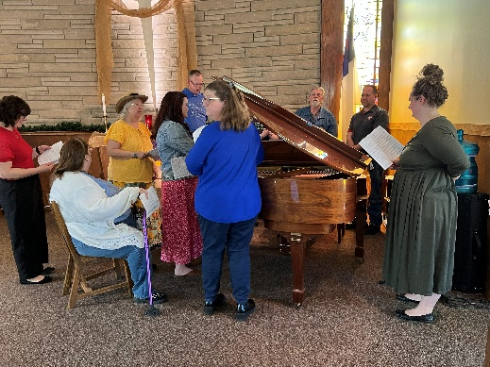
Getting ready for Easter Choir Practice Celebrating 100 Years Young Betty Drake
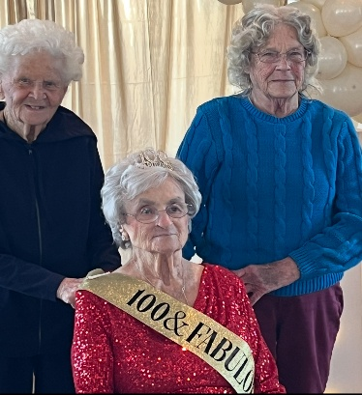

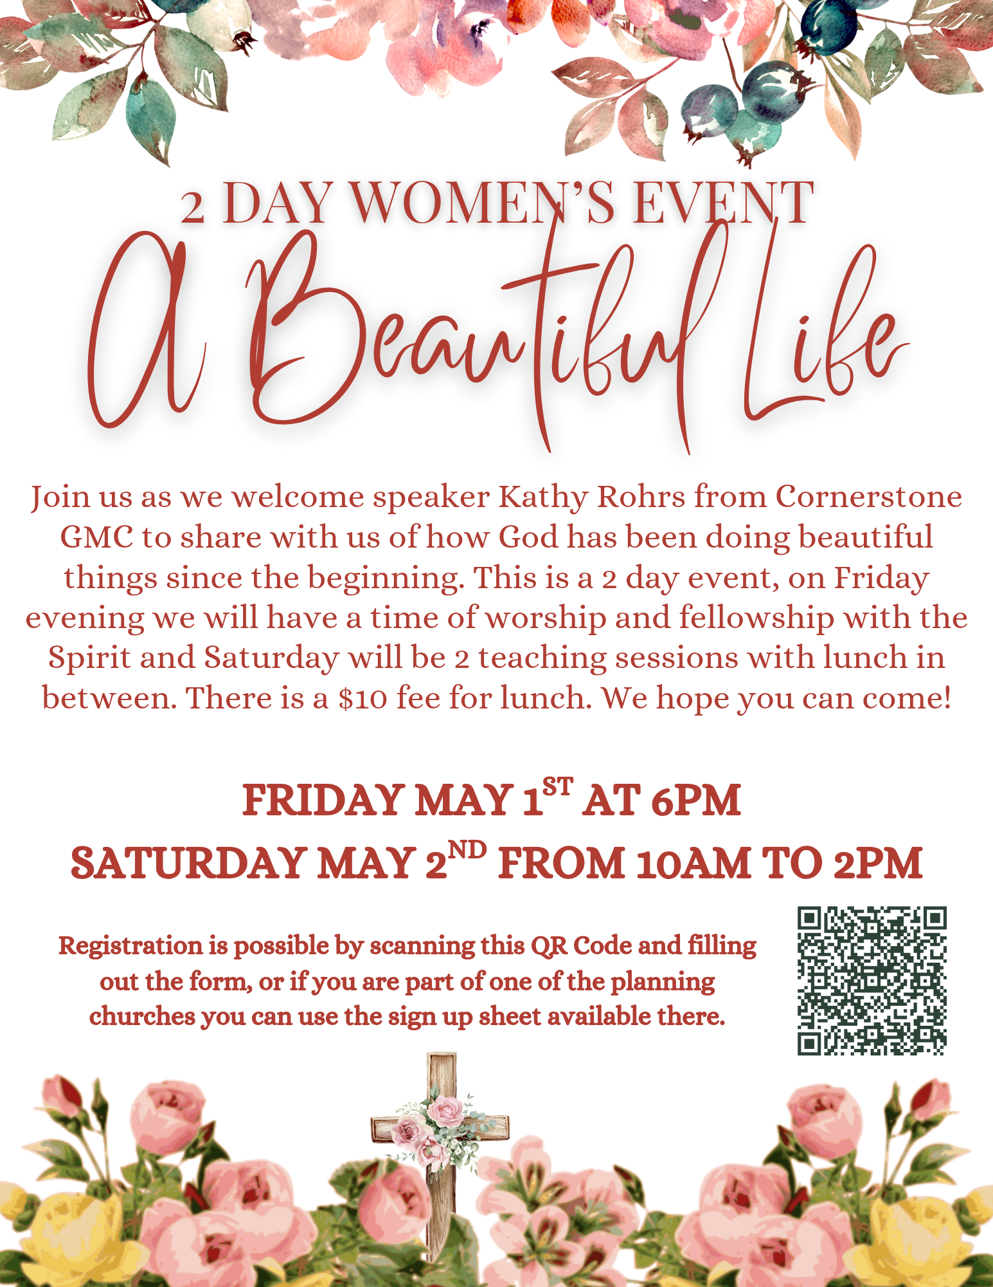
SCIOTO CHAPEL PAGE
. 6337 ST. RT. 316, WEST, ASHVILLE, OH 43103 Sunday Service at 9:00 a.m. www.sciotochapelgmc.org April - May 2026

Can You Envision What Kind of Church You Want?

What a difficult question. Ask twenty people what kind of church they envision and likely twenty different answers would be generated. Ask them to give their vision of the future church and your audience may become silent or stumped at how to respond. Go a step further and ask them to envision the future. The response could be silence.

Envisioning is personal - creating a mental picture or imagining a specific goal, outcome, or future scenario. It takes effort to visualize a goal. Human nature drives us to be “doers” and take action. However, pausing, reflection and mindful planning might be the more successful approach.

To envision is the first step of planning and creating a vision for the future. A vision is a collaborative, strategic process used to create a shared, long-term ideal of the future and takes planning. While visioning is about building a shared future, envisioning is focused on visualizing that possibility.

We have a God given roadmap to help us on the visioning journey. Pastor Brian in a recent sermon gave us a three-part guide: (1) prayerful surrender to God. Don’t go it alone. Put the situation is His hands; (2) be led by the Holy Spirit to guide the process; and (3) take action and be aware that change is difficult but we do not go through this alone. “Do not fear, for I am with you; do not be afraid, for I am your God. I will strengthen you; I will help you...". Isaiah 41:10

Scioto Chapel Administrative Council is ready to embark on a vision exercise and planning process with an experienced leader in the Global Methodist Church. Tom Hanover is a Presiding Elder for the Central West Circuit, a retired elder in our Allegheny West Conference. Tom has many years of experience working with churches of all types and sizes. He will be a great asset to lead us in our process of visioning.

The first vision and planning session with Tom Hanover will be Tuesday April 14th, 6:30pm at Scioto Chapel. The more participants the richer the outcomes. Participants are not limited to any committee or being a member of the church. The only qualification for participation is the desire to contemplate the future of Scioto Chapel and how that future serves you as a Christian, the community and most importantly our Lord and Savior as he directs us to go make disciples who make disciples who make disciples.

And…His Power to Transform: He uses change for good and is constantly creating "new things" (Isaiah 43:19), even turning sorrow into joy and strength.

Patti J. Crego, Co-Chair
Teams 4 Him Scioto Chapel
LENTEN CANDLE UNLIGHTING – Glimpses – Then and Now
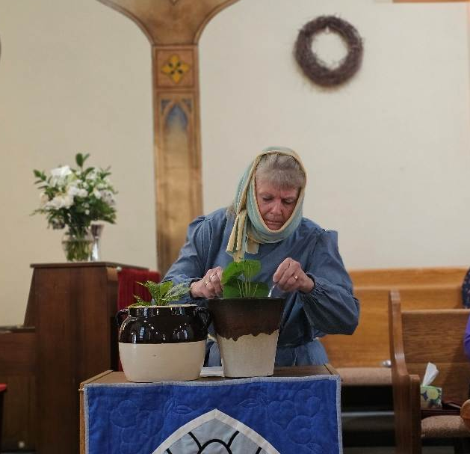
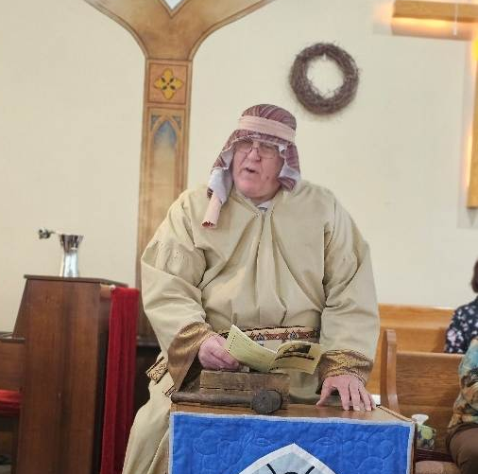

Perry Fausnaugh gave the biblical perspective of a pharisee on the second Sunday and Kathy Morris gave a biblical view of remembrance of her father as he cared for a fig tree on the third Sunday.

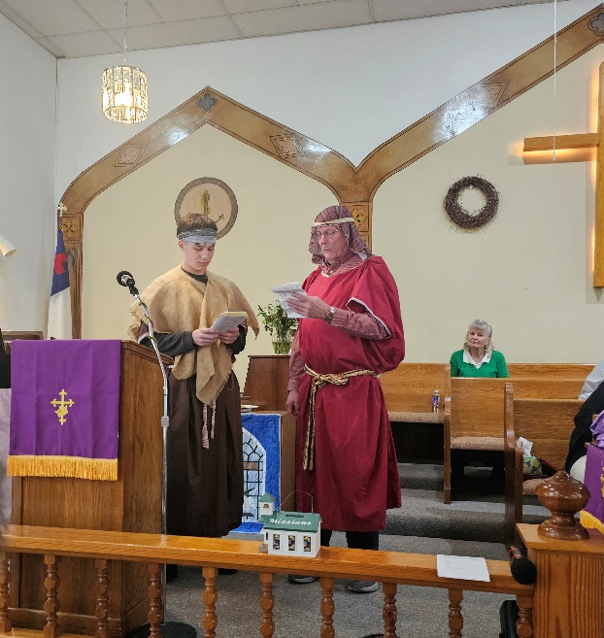
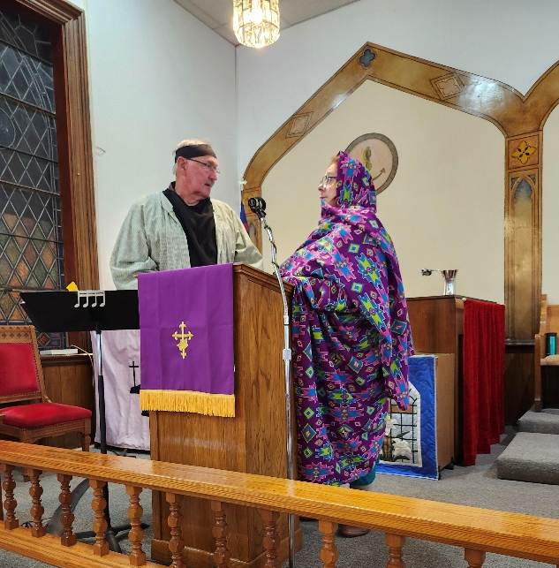

Cooper Goodbar and Lee Stevens gave the biblical account of forgiveness that came about by the prodigal son for the 4th Sunday and Jim Fausnaugh and Becky Davis bickered from the biblical perspective about giving of our time and money to the Lord. Each of these had a counter part that related the stories from the current perspective. There are 2 more services for Palm Sunday and Easter in which Chelsey Gable, Rebecka Crego, Jan Stevens, Betty Fisher, Karen Musselman and Pam West will tell of Jesus entering Jerusalem and Resurrection. Other characters that participated in these skits were Jodi Hastings, Patti Crego, Trey Fausnaugh, Terrie Rogers, Drew Gable and Karan Shipley. We give a big thank you to all these brave folks who added to our Lenten services.

HOLY WEEK SERVICES - There will be Passover Seder Service at GMM at 7:00 p.m. on Thursday and Good Friday service at 7:00 p.m. at Scioto Chapel. Easter Sunrise Service will be at Scioto Chapel at 7:00 a.m. followed by breakfast. And then the chimes will be ringing at the regular service at 9:00 a.m. You don’t want to miss any of these services.

GLOBAL METHODIST GUEST
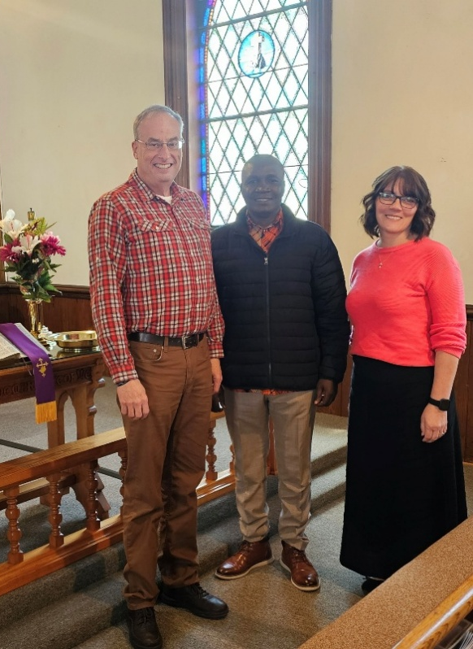
A small number of members from our churches had the privilege of meeting with the Presiding Elder Bonface Wanyama of Nairobi District of Kenya, Africa last weekend. He was with Pastor and Samantha Dunham from Thursday through Saturday and he was making visits in several districts in the USA. We enjoyed a good luncheon on Saturday at our church.
For those who were able to visit with him, it was very inspiring. He gave us plenty to think about as he described the various needs that are in that area of the world and gave us thoughts for ways we could be an outreach to them.
Bonface’s life has truly been directed by our Lord as he told us of losing his parents and separated from his 4 brothers and sisters when he was twelve, but God saw to it that he was placed in a Christian family. He studied early to be a carpenter but God directed him into a more active participation in the church and eventually into the ministry. He advanced higher and higher and is today a very capable and active leader in the Global Methodist Church.

W.C.F. - The church had a very successful Beef and Noodles dinner last month. We served over 200 including the help. We also had some spiritual food for the soul as Pastor Brian was able to have prayer with several of the patrons. At each dinner we have, there are people who have never been here before as well as many who have returned for many years.
We had a breakdown of our mixer as we were making the noodles for this dinner. We praise God as Rick Fruchey was able to find another--used but with all new parts that should serve us for a good while.
The money made at our dinner made a good dent into the expense of the new mixer.
The ladies will be having a mother-daughter luncheon at the church on May 9th at 1:00 pm. Further details will be coming as to whether it will be catered or carry-in. All are welcome.

DISCIPLE BIBLE STUDY –
There will be a short-term discipleship group studying Ephesians to start the Wednesday after Easter at 2:30 pm. Let Pastor Brian know of interest or just show up!

PRAYERS

- Family of “Bud” Baemel
- Blade Ballard is still having problems with vertigo
- Gertie Detwiler’s cancer has returned’
- Family of Sara Boring
- Family of Mrs. Brown
- Darin Dunham recovering from successful surgery from broken tibia
- Tyler & Kim Dunham’s barn fire and loss of goats
- Janette Fausnaugh at home with health issues
- Ron Fausnaugh for strength as care giver
- Sandy Fausnaugh with health issues
- Family of Steve Hines
- HopeStrong at Teays Valley, Westfall and S. Bloomfield
- Jeffersonville new Global Methodist Church
- Mikki Kingsland with double tonsillectomy and broken ankle
- Gary Moore recovery from farm accident
- Mr. Jim with cancer and wife Pam as care giver
- Alec Olsheski with broken collar bone
- Gracie Stout having surgery for a cyst
- Virgil’s grandson serving in Iran
- Wind damage in our area
- Peggy White with declining health
- Prayer Initiative
- Zoom calls with Kenya
- Westfall CARES
- Our Country

PRAISES

- Eileen Dunham’s knee replacement surgery went well
- Pastor Brian and Samantha have twin grandsons-Alex and Ezra



